CENWP-OD-B
23 June 2009
MEMORANDUM FOR THE RECORD

SUBJECT: Dead chinook at Bonneville’s Adult Fish Facility (AFF).

On 23 June at approximately 1530, University of Idaho lamprey researchers reported a dead chinook jack in the AFF to Project Fisheries. Fisheries went to locate the fish at 1600, and found it lying on the cement in front of the upstream AFF entrance, less than two feet above the water. The fish appeared to be in decent condition with minor bird predation marks, but no obvious cause of death. The fish had not been sampled. Information collected is provided below.

- Species – Chinook jack
- Origin – unclipped
- Length – 53.5 cm
- Weight – Unknown
- Marks and Injuries noted during tagging – NA
- Marks and Injuries found on the carcass – Possible bird predation marks, missing eyes
- Cause and Time of Death – Unknown
- Future and Preventative Measures – NA
- Other – The fish was missing both eyes, and a crow had been hovering over it upon arrival.

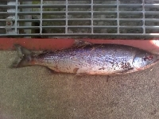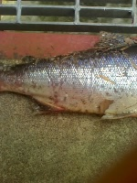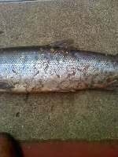

Bonneville Fisheries

